

|  |
| --- |
| **Exciting Websites** |
| [Growing - BBC Bitesize](https://www.bbc.co.uk/bitesize/topics/zbdcy9q/articles/zn6yhbk)  [Keeping clean - BBC Bitesize](https://www.bbc.co.uk/bitesize/topics/zbdcy9q/articles/z7dxjhv)  [Healthy and safe foods - BBC Bitesize](https://www.bbc.co.uk/bitesize/topics/zbdcy9q/articles/zd4qkmn) |
| **Interesting Facts** |
| **Ways to Wellbeing:**   1. **Have good relationships** 2. **Be physically active** 3. **Learn new skills** 4. **Give to others** 5. **Pay attention to the present moment (mindfulness)** |

PSHE: How can we keep healthy as we grow?

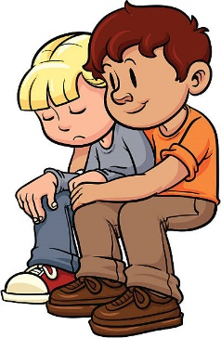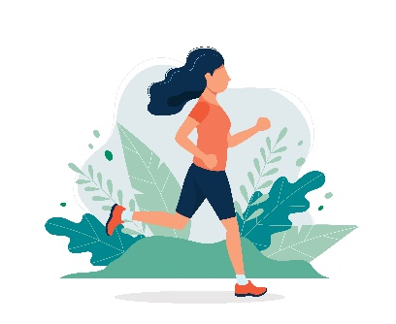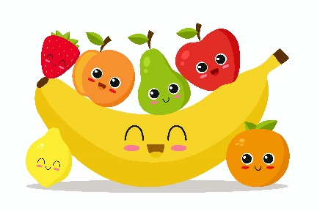

|  |
| --- |
| **Sticky Knowledge** |
| Mental Health - Mental health is all about the thoughts people are having, how they are feeling because of these thoughts and how these thoughts and feelings are affecting their actions and behaviour.  Sometimes people have happy, comfortable thoughts and feelings. Sometimes, people have thoughts and feelings that don’t feel so good and might feel upsetting or uncomfortable. |
| Healthy Mind – Ways of keeping a healthy mind include: talking to others, listening to music, getting fresh air and having enjoyable hobbies. |
| Healthy Lifestyle – In order to have a healthy lifestyle, we must: get enough sleep, plan a healthy diet, maintain good dental health, stay safe in the sun and balance time spent online. |
| Habits – Habits can be healthy or unhealthy. Healthy include: using manners, asking for help and trying your best. Unhealthy include: bullying, thinking you can’t do something and hiding how you feel from others. |
| Drugs – The things that we put into our bodies, including the food we eat, the fluids we drink and medicines, all have an impact on our bodies.  Some things, such as nutrients, vitamins and minerals affect our bodies positively, while other things, such as alcohol and tobacco have a negative effect on our bodies. |
| Early Signs – Signs that someone may be suffering include: persistent low-mood or lack of motivation, not enjoying things they used to like doing, becoming withdrawn and spending less time with friends and family and changes in eating or sleeping habits. |

|  |  |
| --- | --- |
| **Subject Specific Vocabulary** | |
| **Health** | A person's mental or physical condition. |
| **Balanced** | Having different elements in the correct proportions. |
| **Lifestyle** | The way in which a person lives. |
| **Habit** | A settled or regular tendency or practice that is hard to give up. |
| **Drugs** | A medicine or other substance which has a physiological effect when taken. |
| **Strategy** | A plan of action. |
| **Ill-health** | Poor physical or mental condition. |
| **Positive thinking** | Looking at things from a positive point of view. |