

Computing: E-Safety

 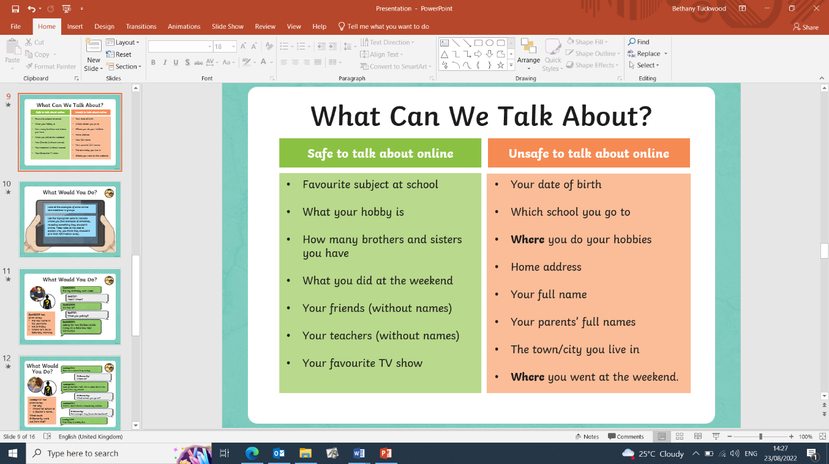

|  |
| --- |
| **Sticky Knowledge** |
| Cyberbullying - the use of electronic communication to bully a person, typically by sending messages of an intimidating or threatening nature. |
| Bullying Vs Cyberbullying – Bullying in person allows the bully to see the person get upset or angry. In cyberbullying, the bully cannot see the effect on the person and this means they are less likely to feel guilty. Other people can’t see that the victim is hurt, and they are less likely to intervene. |
| Secure Sites - If a site is secure it means that any information you put into it is safe: it can’t be seen by anyone else. There are some simple clues you can look for to tell you a website is safe: httpS, padlock, logos and privacy policy. |
| Online relationships – There are benefits and risks to chatting with people online. There are also safe and unsafe things to talk about to people online. If you think that something is serious enough to report to the police, you can ask an adult for advice or help to do this. |
| Stereotypes – It is important to remember that everyone is unique. Girls and boys have different and varied interests and that is ok. We should never judge someone, for example, on what they like doing or how they like to dress. Be you! |

|  |
| --- |
| **Exciting Websites** |
| [Online Safety for Children - Tips & Guides | NSPCC](https://www.nspcc.org.uk/keeping-children-safe/online-safety/)  [Internet Safety Guide for Kids | SafeWise](https://www.safewise.com/resources/internet-safety-kids/)  [Safer Internet Day - Teaching Resources - BBC Teach](https://www.bbc.co.uk/teach/safer-internet-day-resources/z6bbhbk) |
| **Interesting Fact!** |
| **Always be SMART:**  **S – Safe**  **M – Meeting**  **A – Accepting**  **R – Reliable**  **T - Tell** |

|  |  |
| --- | --- |
| **Subject Specific Vocabulary** | |
| **Cyberbullying** | The use of electronic communication to bully a person, typically by sending messages of an intimidating or threatening nature. |
| **Secure** | Certain to remain safe and unthreatened. |
| **Fraud** | A person or thing intending to deceive others. |
| **Personal Information** | Information identifiable to any person such as address. |
| **Gender** | Either of the two sexes (male and female). |
| **Stereotype** | A well-known idea or image of a group of people, that is held by a number of people. |
| **Media** | The main means of mass communication, such as television and radio broadcasts, publications (newspapers and magazines) and the internet. |